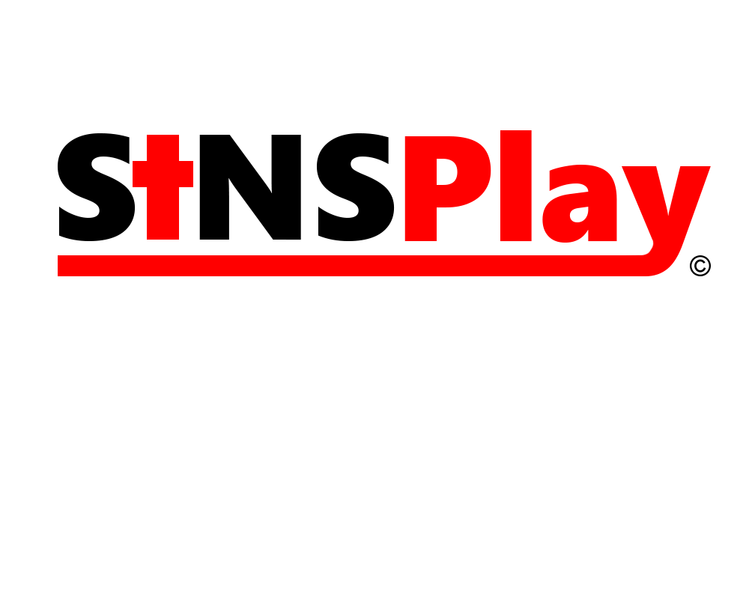

**Unity Game Developer – Action Role-Playing Game (RPG)**

**SinsPlay**.– Northridge, CA 91325

If you are interested becoming a Unity Game Developer please read on!

Based in one of the top Universities, CSU, Northridge; we are providing an opportunity for game designers to come together and build an awesome Action RPG for the web. We are an exciting, diverse, and innovative company that specializes in Role Playing Games.

Due to the growth and demand for our services, we are interested in hiring a couple of Unity Game Developers.

Developers will build more experience as they grow with the company and learn many new techniques and tactics about Unity. If you are interested in joining the team, and want to bring Action RPG’s back to life, apply immediate while spaces are limited.

**What You Will Be Doing**

* Writing reusable, high performance codes for our Unity application using C#
* Communication through Slack, Discord, or Skype
* Using GitHib, and Google Docs to share documents and code.
* Integrate Unity’s application API
* Optimization of application
* Engage in team meetings
* Creating and testing game

**What You Need For This Position**

* Interested in game designing
* Must be a game enthusiast
* Motivated to learn and create

**What we are Looking For**

* Experienced Unity Users
* Game Enthusiasts
* Team Players
* Artists

**What’s in It for You**

* Thanksgiving break
* One week off during winter break
* Become a shareholder of the company

**Job Type:** Part-Time

**Job Location:** California State University, Northridge @ JD Hall 1310

**Requirements:**

* Positive attitude
* Has a working computer compatible with Unity
* Dedicate 3-5/hr a week in the company

If you think you qualify for this position, please apply now!

**Contact:**

**Gmail:** [SinsPlay490@gmail.com](mailto:SinsPlay@gmail.com)

**Instagram:** SinsPlay

**Facebook:** SinsPlay

**YouTube:** SinsPlay

**Snapchat:** @SinsPlay

**Twitter:** @SinsPlay.